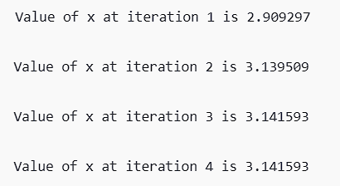

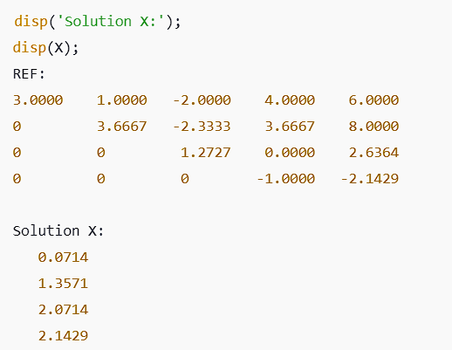

Without Partial Pivoting
A = [2 -1 3 4; 1 3 -2 1; 4 2 1 -3; 3 -1 2 5];
B = [5; 6; 7; 8];

for j = 1:3
for i = j+1:4
f = A(i,j) / A(j,j);
A(i,:) = A(i,:) - f * A(j,:);
B(i) = B(i) - f * B(j);
end
end

REF = A;
REF(:,5) = B;
disp(REF);

X = zeros(4, 1);
X(4) = REF(4, 5) / REF(4, 4);

for i = 3:-1:1
X(i) = (REF(i, 5) - REF(i, i+1:4) * X(i+1:4)) / REF(i, i);
end
disp(X);
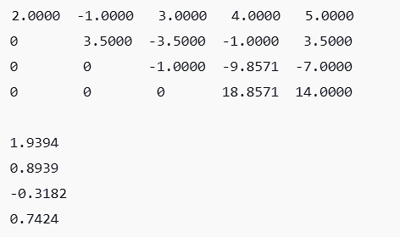
disp('Solution of the system with iterative method is');
disp(x1);
disp(x2);
disp(x3);

disp('Solution with MATLAB functions:');
disp(S);

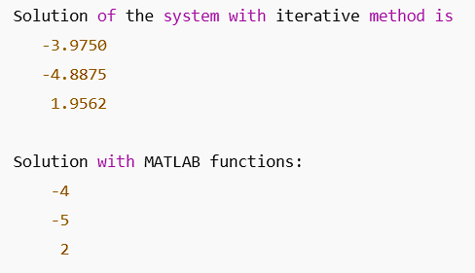

disp('Solution with matlab functions:');
disp(x);
disp(S);
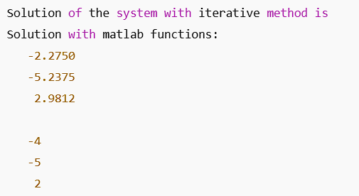

PRACTICAL-5
OBJECTIVE : Program to implement Power Method for finding maximum eigen value and corresponding eigen vector
A = [4 1; 2 3];
x = [1; 1];
tol = 1e-6;
max_iter = 100;

lambda_old = 0;
num_iterations = 0;

for k = 1:max_iter
x_new = A * x;
lambda = max(abs(x_new));
x = x_new / lambda;
num_iterations = num_iterations + 1;

if abs(lambda - lambda_old) < tol
break;
end

lambda_old = lambda;
end

disp('Eigenvalue:');
disp(lambda);

disp('Corresponding Eigenvector:');
disp(x);

disp('Number of Iterations:');
disp(num_iterations);
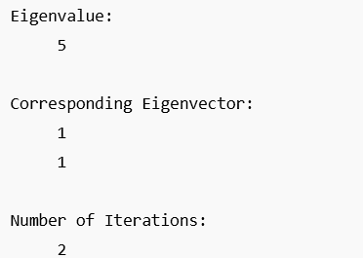

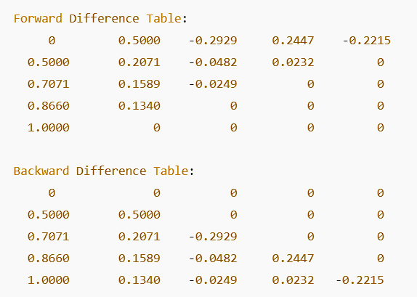

PRACTICAL-7
OBJECTIVE : Program to implement Lagrange’s Method of Interpolation
syms x;
x_val = [1 2 3 5];
y = [10 4 4 7];
n = length(y);
L = sym(0);

for i = 1:n
L_i = sym(1); % Initialize L(i) as 1
for j = 1:n
if i ~= j
L_i = L_i * ((x - x_val(j)) / (x_val(i) - x_val(j)));
end
end
L = L + L_i * y(i);
end

P_x = simplify(L);
fprintf('The interpolating polynomial is: ');
disp(P_x);


I = I + 4 * f(x);
end
end
ans = (h / 3) * I;
disp(ans);

otherwise
disp('Invalid input');
end
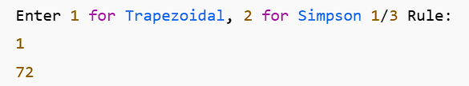

PRACTICAL-9
OBJECTIVE : Program to implement Runge-Ku a Method for solving ODE
f = @(x, y) -x^2 + 1;
h = 0.2;
x = 0;
y = 0.5;

fprintf('Step 0: x = %12.8f, y = %12.8f\n', x, y);

for i = 1:4
K1 = h * f(x, y);
K2 = h * f(x + h/2, y + K1/2);
K3 = h * f(x + h/2, y + K2/2);
K4 = h * f(x + h, y + K3);
y = y + (K1 + 2*K2 + 2*K3 + K4) / 6;
x = x + h;

fprintf('Step %d: x = %6.4f, y = %18.15f\n', i, x, y);
end
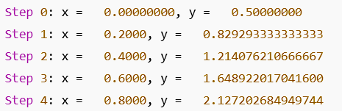

PRACTICAL-10
OBJECTIVE : Program to implement Picard’s Method for solving ODE
syms x y
f = x + y^2;
Y = 0;
x_val = 0.3;

for i = 1:3
F = subs(f, Y);
f(x) = int(F, 0, x);
Y = f(x);

fprintf('The value of y for iteration %d is %10.8f\n', i, double(subs(f(x), x, x_val)));
end
